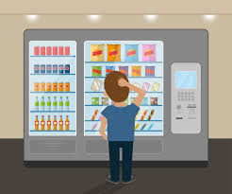

End-User Manual

Vending Machine

Team work 5

2018

# End user documentation

The purpose of this document is to help the user understand certain aspects of the systems and to provide all the answers in one place:

1. What is a vending machine?

* A machine that dispenses small articles such as food, drinks, or cigarettes when a coin or token is inserted into it.

1. How does the vending machine work?

* Choice of items with their prices

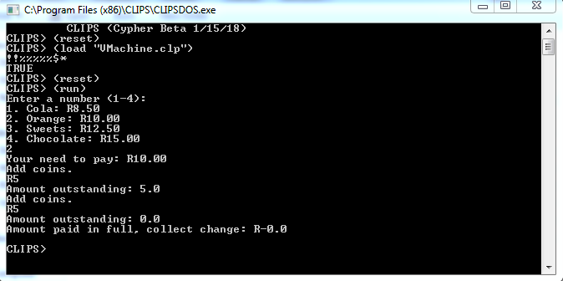Cola 8.50, orange 10.00, sweets 12.50, chocolate 15.00

* The vending machine accepts payment with the following units:

R5, R2, R1, c50, c20, c10

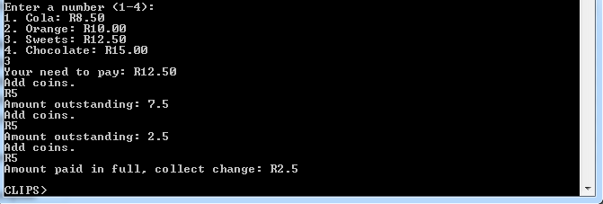

* 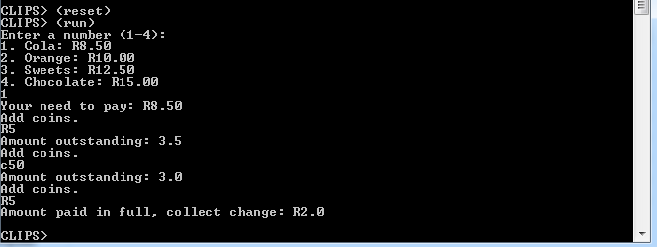The machine indicates the amount the user has entered and calculates change and gives it back to the user.